
Kohlfurter Straße 2, 90473 Nürnberg, Germany, 0049/(0)911/808896, www.millipederecords.de, info@millipederecords.de

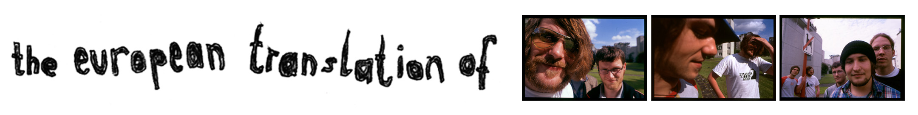

Band: The European Translation Of Titel: Lights We Stole To Let Stars Sparkle
Catalogue number: Milli008 Format: CD/LP
Release date: 01.06.2003 Country of origin: Germany
Playing time: 38:51

Songs:
01. All Flights Cancelled 07. 1000 Chords
02. Lean Your Head On Hope And Vaporize 08. Petty Bourgeoise
03. Substitute For The Thrill In Our Lives 09. A Healthy Nature Spot
04. Congratulations, An Acquittal 10. When I Go By
05. Verve And The Ruins Of Diligence 11. The Public Prosecutor’s Final Speech
06. How To Close This Book

Info:
It all began in 2001, as The Flamingo Massacres and Oliver Twist were playing in Straubing. There was no good local support, so one decided to make a new band project ready within 1 month to fill the support slot. The European Translation Of was born. The live set of that evening soon became their first demo „Cesarian Cut EP“. The band in the beginning was 2/4 of the postrock formation „Plus Ganzwind“ that is distributed via „Schinderwies Productions“. On the second demo „Go On Excursion“, Matthias Lehrberger, who is also known as Auf Dem Weg Ins Kaufhaus Erledigte Ich Noch Schnell Einen Kleinen Hauskauf, where he releases electronic music in the veins of Oval, switched from drums to guitar. He left the band shortly before the recording session for the debut album „Lights We Stole To Let Stars Sparkle“ and was replaced by Dominik Lutter, who meanwhile also left the band. That’s quite typical for the band. In 3 years, about 15 people played in changing 4 or 5 piece line ups. On the album, there are still 3 songs on which Matthias Lehrberger took part in the writing process. The rest of the record was written by the new line up. Meanwhile, the band decided not to look for a new guitar player but have a keyboard player now. The new songs are really a progress and can be heard on the Split CD with The Nationale Blue from Boston. The band recorded 6 new songs featuring Thomas from The Robocop Kraus and did their best work so far.

In 2003 the album is being promoted live and suddenly the band finds itself on the Sant Filu Hardcorefest in Spain, playing with bands like Blood Brothers, Pretty Girls Make Graves, JR Ewing und Poison The Well. Other shows follow with bands like The Oliver Twist, North Of America, The Robocop Kraus, or The Locust. Plans are being made to record a split release with their friends from North Of America, but they decided to split up and not record any new songs. After looking for a good partner for the split, it soon got clear that The Nationale Blue would be the perfect band. The band also recorded a cover of Fugazi’s Blueprint for a Dischord Tribute CD on Millipede Records that was released in summer 2004. Another cover song for a Sucicide Hotline Benefit followed. This time it’s a song by an all time legend, „Joy Division“. On this CD they are in good company with bands like Tomte, The Robocop Kraus, Tagtraum, Là Par Force and Muff Potter.

So what can you expect in the future? Instead of 2 guitars, there’s only 1, but keyboard. A big step for some people, but it didn’t mean that much change for the band. The songs will be worked out together in the session room and some new influences are discussed. That means the band will develop in a natural way. Where in the beginning, North Of America and old Les Savy Fav could be heard, you’ll find song-structures more influenced by newer Les Savy Fav and some U2-oriented Pretty Girls Make Graves now. The formula is still indie guitars, the energy of post-hardcore and elements screamo.

Points of interest:
- New album at end of this year
- Tour in september
- Song on the Millipede Records Promo compilation (5000 pieces)

Label contact:
Millipede Records, Kohlfurterstraße 2
90473 Nürnberg, Germany
Phone: 0049/(0)911/808896
info@millipederecords.de

On the web:
www.millipederecords.de
www.theeuropeantranslationof.de
http://www.myspace.com/europeantranslation

